European Journal of Tourism, Hospitality and Recreation
https://sciendo.com/journal/EJTHR

Title (Style: Cambria, 12 Points, Bold)

Abstract
The Abstract should be a single paragraph with a maximum of 200 words. It is important that in this topic of the article there are no references and, no abbreviations or acronyms. It should contain the following topics: (1) Purpose: highlight the research question and state the purpose of the research; (2) Methodology: describe the methods used in the article summarised; (3) Results: summarise the results obtained; (4) Conclusions: present the main conclusions drawn from the results; (5) Implications: clarify how the results contributed to the research question.
Keywords: keyword 1; keyword 2; Keyword 3; Keyword 4; Keyword 5; Keyword 6 (List until six keywords to help readers find your article)

Introduction (Style: Cambria, 14 Points, Bold)

In the Introduction section, you should explain the topic briefly and in a broad context. It should also include the objective and the importance of the article. In this part, you can use references from other authors. The main aim, methodology and conclusions of the article should be resumed in a concise form. The Introduction section should be written in simple and comprehensible language to readers working outside the topic. (Style: Cambria, 12 Points, Double spacing)

Literature Review (Style: Cambria, 14 Points, Bold)

In this section, you should use studies by other researchers to explain concepts and problems about your paper that will be analysed throughout the manuscript. In the Literature Review, you must include citations and references placed correctly and according to the APA standards. Here you should also expose the scientific hypotheses to be tested. (Style: Cambria, 12 Points, Double spacing)

Methodology (Style: Cambria, 14 Points, Bold)

The methodology should be written concisely, however it needs to provide the necessary details so that other people can reproduce them and can draw on the results. It can be supported by citations. If you use more than one method, you can divide this section into subsections. All data, codes and materials should be available to readers, however, the restrictions of these should be expressed. If you use an open source database, you must identify where it was taken from. If your article requires ethical approval, you should identify that authority, along with the code. (Style: Cambria, 12 Points, Double spacing)

Style settings (Style: Cambria, 12 Points, Bold)

    - Headings (Style: Cambria, 12 Points, Italic)

- First-level headings (e.g. Introduction, Literature Review, Methodology, Results, Discussion, Conclusions): with an initial capital letter for any proper nouns (style: Cambria, 14 Points, Bold);
- Second-level headings: with an initial capital letter for any proper nouns (style: Cambria, 12 Points, Bold);

- Third-level headings: should be in italics, with an initial capital letter for any proper nouns (style: Cambria, 12 Points, Italic);
- Fourth-level headings: should be in italics, at the beginning of a paragraph. The text follows immediately after a full stop (full point) or other punctuation marks (style: Cambria, 12 Points, Italic).

Results (Style: Cambria, 14 Points, Bold)

The section may be divided into subsections. The description of the results obtained should be clear and precise and be accompanied by interpretations and conclusions.

Figures and tables (Style: Cambria, 12 Points, Bold)

You must create tables using Microsoft Word or exporting from Microsoft Excel. Please supply editable files.
All illustrations, figures, and tables are placed within the text at the appropriate points, rather than at the end. Please note that images supplied in colour will be published in colour online and black and white in print (unless otherwise arranged). Therefore, it is important that you supply images that are comprehensible in black and white as well (i.e. by using colour with a distinctive pattern or dotted lines). The captions should reflect this by not using words indicating colour. All figures must be numbered in the order in which they appear in the paper (e.g. Figure 1, Figure 2, or Table 1, Table 2).
Figures should be high quality (1200 dpi for line art, 600 dpi for grayscale and 300 dpi for colour, at the correct size). Figures should be supplied in one of our preferred file formats: JPEG, GIF, or Microsoft Word (DOC or DOCX).

All figures and tables should be accompanied by a simple legend. The legends should be centred, Cambria font and 10 points in size. See the below examples:

Figure 1 - Logo of European Journal of Tourism, Hospitality and Recreation

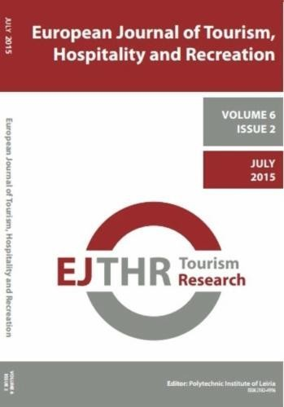
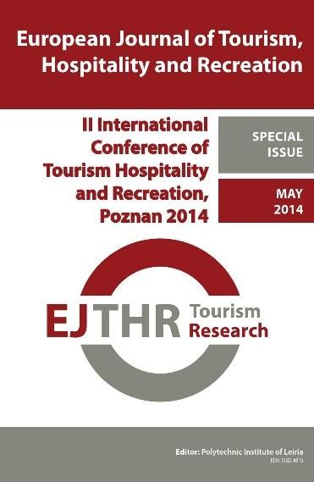
(a) (b)
Figure 2 - Figure with 2 subgraphs: (a) description of the contents of the first subgraph; (b) description of the contest of the second subgraph

Table 1 - Parameters of model

Title | Topic | Value
A | A+B | 200
B | X=Y+Z | 500

Equations

You should use Microsoft Word or Microsoft Equation Editor to write and edit your equations. Mathematical formulae should be placed and numbered throughout,

for example, Eq. (1) or Eqs. (2) - (5). Numbering is placed to the right. (Sytele: Cambria, 10 points, spacing before and after the equation – 10 points). See the follow example:

cos 𝛼 + cos 𝛽 = 2 cos 1 (𝛼 + 𝛽) cos 1 (𝛼 − 𝛽) (1)
2 2

Units, symbols and physical quantities

Physical quantities, as well as units of measurement should be in accordance with the International System of Units (SI), in abbreviated form. Dots should be used to separate values, for example: 1.15 and not 1.15.

Discussion (Style: Cambria, 14 Points, Bold)

In this section, the authors should analyse the results obtained together with the data obtained in the Literature Review and with the research hypotheses. They should also present the results and implications of the research. (Style: Cambria, 12 Points, Double spacing)

Conclusions (Style: Cambria, 14 Points, Bold)

This section should contain the main conclusions that the authors reached with the research, revealing its significance. It may express the limitations of the work and guidelines for future research. (Style: Cambria, 12 Points, Double spacing)

Funding (Style: Cambria, 14 Points, Bold)

For single agency grants

This work was supported by the [Funding Agency] under Grant [number xxxx].

For multiple agency grants

This work was supported by the [Funding Agency #1] under Grant [number xxxx]; [Funding Agency #2] under Grant [number xxxx]; and [Funding Agency #3] under Grant [number xxxx].

(Style: Cambria, 12 Points, Double spacing)

Disclosure statement (Style: Cambria, 14 Points, Bold)

This is to acknowledge any financial interest or benefit that has arisen from the direct applications of your research. (Style: Cambria, 12 Points, Double spacing)

Data availability statement (Style: Cambria, 14 Points, Bold)

If there is a data set associated with the paper, please provide information about where the data supporting the results or analyses presented in the paper can be found. Where applicable, this should include the hyperlink, DOI or other persistent identifier associated with the data set(s). (Style: Cambria, 12 Points, Double spacing)

Acknowledgements (Style: Cambria, 14 Points, Bold)

You can thank all the people who have contributed to the article. (Style: Cambria, 12 Points, Double spacing)

Conflicts of Interest (Style: Cambria, 14 Points, Bold)
They must include the following if there is no conflict of interest "The authors of the article "xxxx" declare no conflict of interest". If they do, the following should be

included: "Author xxxx serves as a paid consultant/member/expert at Y". (Style: Cambria, 12 Points, Double spacing)

References (Style: Cambria, 14 Points, Bold)

Please follow the instructions of the APA seventh edition standards. You may consult examples in the following link: https://apastyle.apa.org/instructional- aids/reference-examples.pdf.
(Style: Cambria, 12 Points, Double spacing)

Appendix (Style: Cambria, 14 Points, Bold)

You may include annexes in your article. They should be properly identified in this section, as well as throughout the article. You can place tables, images, more detailed explanations, among others. (Style: Cambria, 12 Points, Double spacing)

Note: You must obtain the necessary permission to reuse third-party material in your article. The use of short extracts of text and some other types of material is usually permitted, on a limited basis, for the purposes of criticism and review without securing formal permission. If you wish to include any material in your paper for which you do not hold copyright, and which is not covered by this informal agreement, you will need to obtain written permission from the copyright owner prior to submission.

